**Ex No 3 INHERITANCE**

**Date :**

**Aim:**

To execute and verify a Java program that prints all the details of point and moving the point by the given value.

**1 a**. 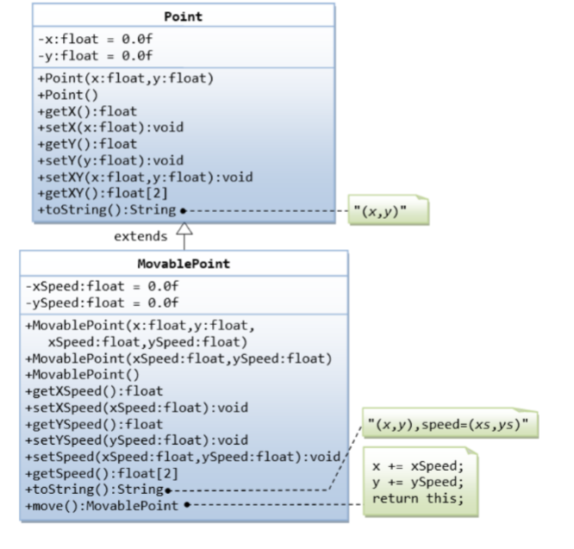

**Algorithm:**

1.START

2. Create a main class with a suitable name.

3.Define the `main` method within the class: `public static void main(String[] args) { ...

4.Create a parent class with the given name- point.

5. Declare the variables required such as floating x and y.

6. Initialize the variables declared as 0.0f.

7. Create new methods as per the given question as getX() and getY().

8. Create a child class Movable point and inherit the parent class

9. Declare and initialize the necessary variables.

10. Create a new method move, to move the pointer position.

11. Within the main class the output is printed along with the manipulated values.

12.STOP

**Program:**

class Point {

float x;

float y;

public Point(float x, float y)

{

this.x = x;

this.y = y;

}

public Point() {

this(0.0f, 0.0f);

}

float getX()

{

return x;

}

float getY()

{

return y;

}

}

class MovablePoint extends Point {

float xSpeed;

float ySpeed;

public MovablePoint(float x, float y, float xSpeed, float ySpeed) {

super(x, y);

this.xSpeed = xSpeed;

this.ySpeed = ySpeed;

}

public MovablePoint(float xSpeed, float ySpeed) {

this(0.0f, 0.0f, xSpeed, ySpeed);

}

public MovablePoint() {

this(0.0f, 0.0f, 0.0f, 0.0f);

}

public MovablePoint move() {

x += xSpeed;

y += ySpeed;

return this;

}

}

public class Main {

public static void main(String[] args) {

MovablePoint point = new MovablePoint(1.0f, 2.0f, 0.5f, 0.5f);

System.out.println("Initial position: (" + point.x + "," + point.y + ")");

point.move();

System.out.println("After moving: (" + point.x + "," + point.y + ")");

Point obj = new Point();

obj.getX();

obj.getY();

}

}**Output:**

Initial position: X 1.0, Y 1.0

After moving: X 1.5, Y 1.5

1 . Write a program that illustrates method overriding. Class bond is extended by  
convertiblebond. Each of these classes defines a display() method that outputs the String  
“Bond” or “ConvertibleBond” respectively. Declare an array to hold six Bond objects.  
Initialize the elements of the array with a mix of Bond and convertible bond objects.

**Algorithm:**

1. START
2. Create a parent class Bond and print some bond objects.
3. Create a child class Convertible bond that inherits from the parent class and print some convertible bond objects.
4. Create the main class with a suitable name.
5. An array of 6 is initialized as per the given question.
6. Create objects for the classes.
7. Finally call the objects and print the output.
8. STOP

**Program:**

class Bond {

public void display() {

System.out.println("Bond");

}

}

class ConvertibleBond extends Bond {

public void display() {

System.out.println("ConvertibleBond");

}

}

public class InheritanceJava{

public static void main(String[] args) {

Bond[] bonds = new Bond[6];

bonds[0] = new Bond();

bonds[1] = new ConvertibleBond();

bonds[2] = new Bond();

bonds[3] = new ConvertibleBond();

bonds[4] = new Bond();

bonds[5] = new ConvertibleBond();

for (int i = 0; i < bonds.length; i++) {

bonds[i].display();

}

}

}

**Output:**

Bond

Convertible Bond

Bond

Convertible Bond

Bond

Convertible Bond

Bond

Convertible Bond

Bond

Convertible Bond

Bond

Convertible Bond

|  |  |
| --- | --- |
| **Code/output(15)** |  |
| **Quiz(5)** |  |
| **Record(5)** |  |
| **Total(25)** |  |
| **Initial** |  |

Result :

The given programs were executed and verified by using JAVA.